Your Neighbors, Incorporated

PURPOSE…
We’re reaching out to neighbors in the greater Utica area. Trained, dedicated volunteers are at the heart of the program. The Program Director receives a referral from an agency or individual, determines needs, and matches a volunteer with a neighbor. A bond is formed as the relationship develops; one-to-one contact assures a quality response.

SERVING OUR COMMUNITY
- Information and referral
- Collaboration with other community agencies
- Screening of referrals
- Volunteer training and badges
- Supervised allocation of resources
- Advocacy for the homebound
- Regular newsletter communication
VOLUNTEERS
EXTENDING A HAND…
The link is forged when the friend and neighbor are introduced. The relationship is strengthened through regular follow-up and communication among friends and volunteers. Each friendship grows and flowers in its own way.
Volunteers meet a need by providing support and helping to maintain independent home living by:
- Helping meet transportation needs
- Being a friendly visitor
- Providing telephone reassurance
- Preparing meals
- Promoting community awareness
- Giving of your time in other ways
WHO ARE OUR VOLUNTEERS?
People who are willing and able to share with others – committed to caring, responding to needs, giving of themselves.
In other words…
YOU!

MEETING A NEED…
…By providing support and helping to maintain independent home living.

Your interest in Your
Neighbors is valued.
For more information about becoming a volunteer or obtaining services,
please call (315) 732-6804
or go to our website…
www.yourneighborsinc.com
Our office is located upstairs at
Our Savior Lutheran Church
1604 Genesee St.
Utica, NY 13502
Address mail and donations to:
Your Neighbors, Inc.
P.O. Box 564
New Hartford, NY 13413
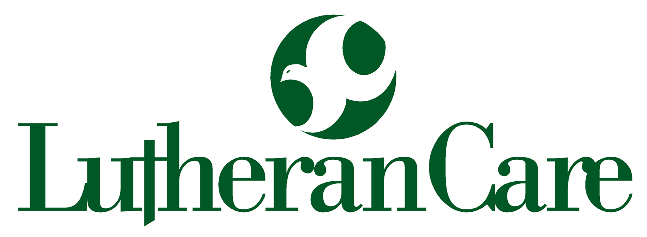
An affiliate of the Lutheran Home
of Central New York

Our prepared meals are stored in several centrally-located freezers in the Utica area |  | No fees are charged for any service |  | Your Neighbors, Incorporated,  is a private not-for-profit agency

REACHING OUT…
Volunteers Say:
“She needed fellowship, and I had a need to find someone to give to.”
“God must have put us together,
because I enjoy her.”
“He needs someone to share with and listen with his heart.”
“The day after Thanksgiving, I found her refrigerator totally empty except for a quart of milk.”

RESPONDING…
Friends Say:
“It’s like sunshine in my life.”
“I never thought I would find a friend like her.”
“It’s wonderful that people still care about me.”
“I can’t afford to pay for taxies…you people really help.”
“The meals are always wonderful and I appreciate every person who makes them.”

YOU can help, too!
Be a part of the community
outreach effort…
BE A VOLUNTEER!

Tell others about
Your Neighbors, Inc.

For more information,
contact Program Director at
(315) 732-6804
yourneighborsinc@yahoo.com
or visit
www.yourneighborsinc.com

Mission Statement
Your Neighbors, Inc., is dedicated to providing quality service and support to people who are frail, elderly, or have a disability in their home setting. Our volunteers offer friendly visits, medical transportation, supplemental frozen meals, and specialized shopping
services.
P.O. Box 564
New Hartford, NY 13413
(315) 732-6804
© 2008 YNI TFSTP0415

YOUR NEIGHBORS,
Inc.
 | YOUR NEIGHBORS,  Inc.
An affiliate of the Lutheran Home
of Central New York
Bright
Beginnings…
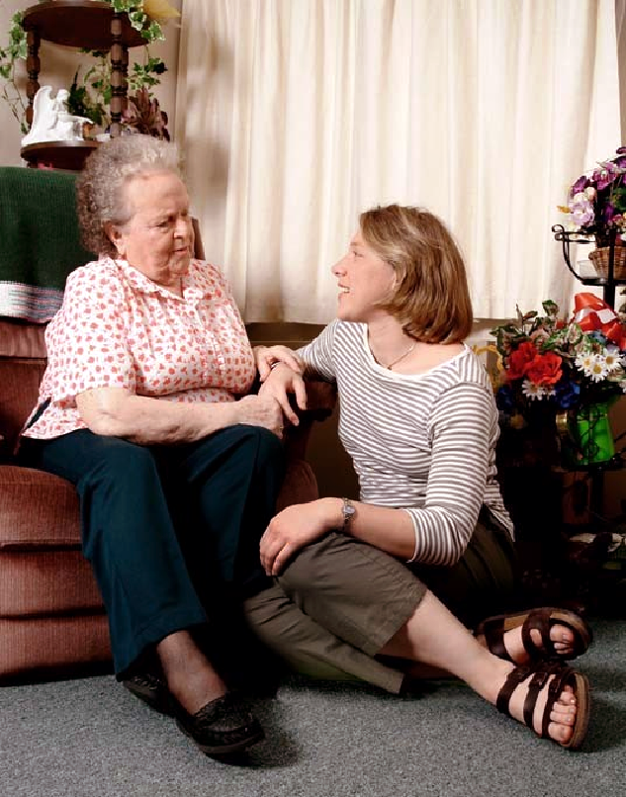
…Where
Friends
Meet!
A Neighbor’s Independence Depends On
You!
Go to our website at:
www.yourneighborsinc.com

